Pre-Interview Project Solution

1. **The Bug in the URL network response**

The error in the URL - <https://osa-web.t-cg.co.uk/qatest> not landing on News page is due to incorrect response from one of the network calls “news?markAsRead=false”.

* 1. Here the requested URL - <https://pro-fapi-osa.t-cg.co.uk/api/schools/4055/news?markAsRead=false> fetches the value of organisationID for URL - <https://osa-web.t-cg.co.uk/news> so all the news are listed down. But for the URL - <https://osa-web.t-cg.co.uk/qatest> the organisationId is not updated so the Requested URL is <https://pro-fapi-osa.t-cg.co.uk/api/schools/organisationId/news?markAsRead=false> . So the response status is 404 in the latter URL.

**The correct response for** [**https://osa-web.t-cg.co.uk/news**](https://osa-web.t-cg.co.uk/news)

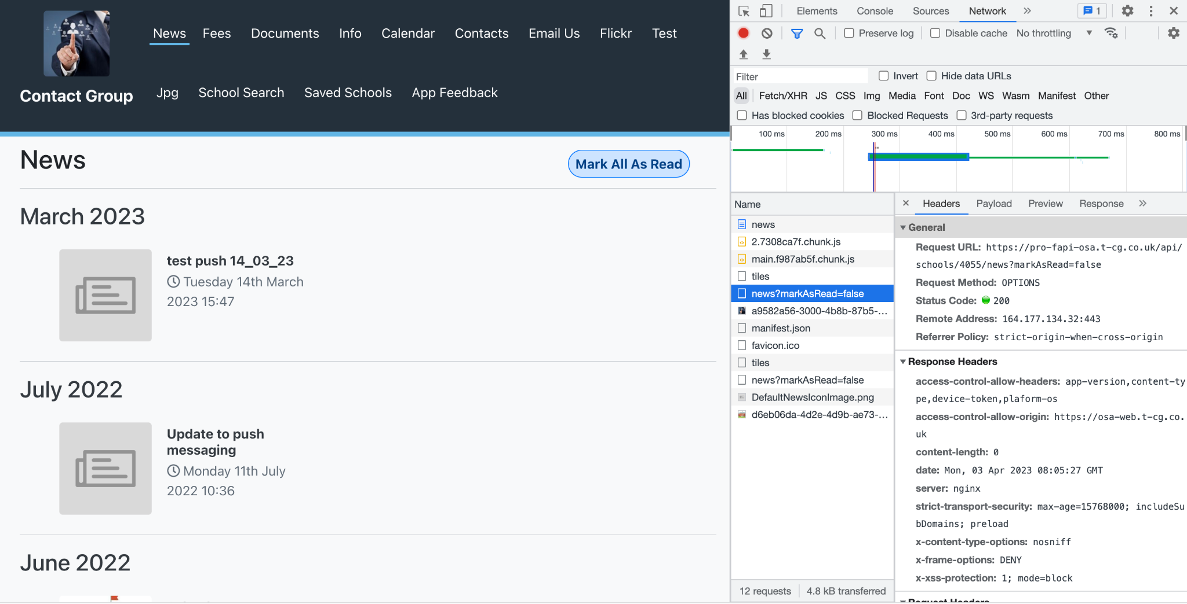

**The failed network response for -** [**https://osa-web.t-cg.co.uk/qatest**](https://osa-web.t-cg.co.uk/qatest)

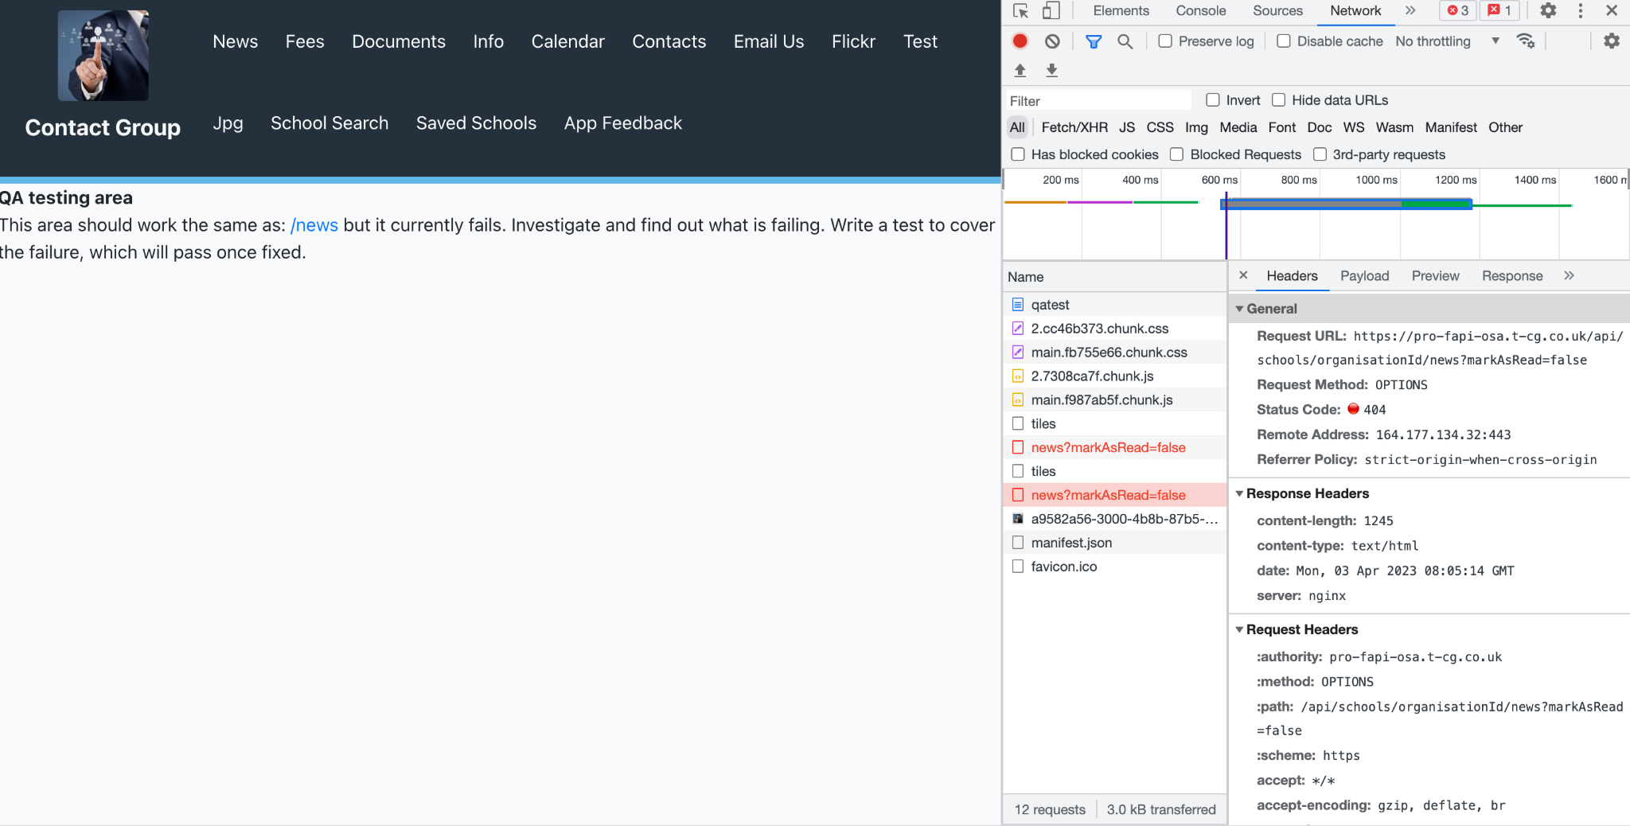

1. **The fix for the following issue**
   1. If the requested URL for “news?markAsRead=false”, is passed with proper organisationID then the issue would be resolved
2. **How can one view the issue**
   1. To view the issue one can launch both the URLs to the destined page.
      1. Right click and select inspect
      2. Click the network tab and see the network traffic and check which requests are failed
      3. The request with status code 404 is said to be faile and the error is due to the same.